
Department of Computer Science and Engineering DevOps Lab - L3

Lab Assignment No: 10
Name of Student | Atharva Rale
PRN | 23070122174
Batch | 2023 – 2027
Class | CSE – B1
Academic Year & Semester | 2026 - 2027, 7th Semester
Title of Assignment | Docker Volumes & Data Persistence
Implementation & Theory | 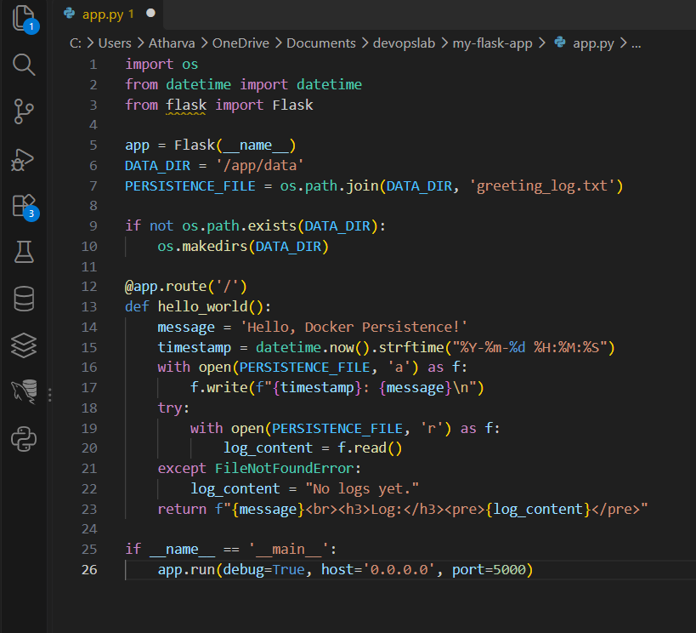  app.py updated — Modified the Flask app to write a timestamped log entry to /app/data/greeting_log.txt on every request, and read back the accumulated log to display in the response — setting up a testable persistence check.

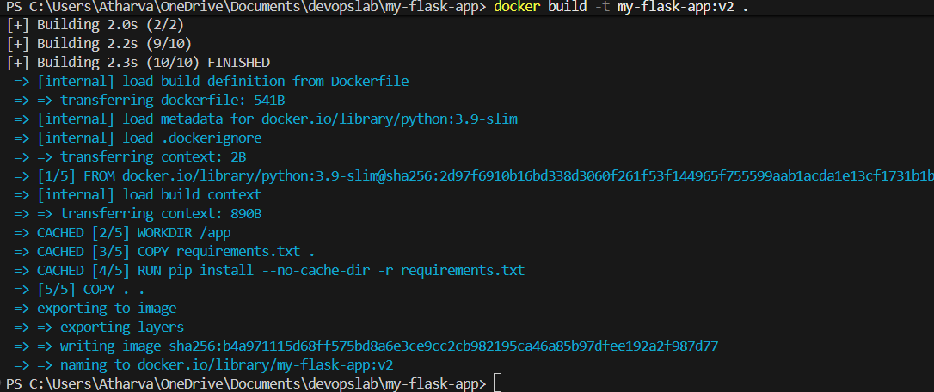
Image rebuilt — Built a new image tagged my-flask-app:v2 incorporating the updated app code.
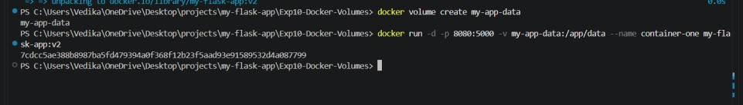

Named volume created — Created a Docker volume my-app-data; verified its existence with docker volume ls --filter
name=my-app-data.
Container run with volume mounted — Started a detached container from my-flask-app:v2, mounting my-app-data to /app/data inside the container.

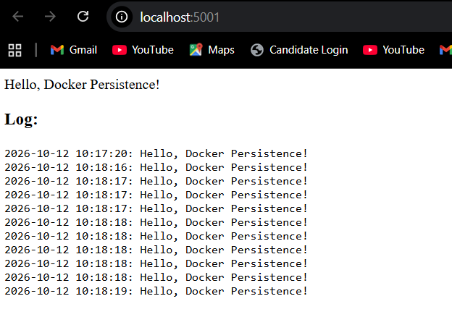
Verify writes accumulate — Refreshed http://localhost:5001 multiple times; each refresh appended a new timestamped entry to the visible log, confirming writes were landing on the mounted volume.

Stop and remove container — Stopped and removed the container entirely (docker stop + docker rm), leaving only the named volume behind.

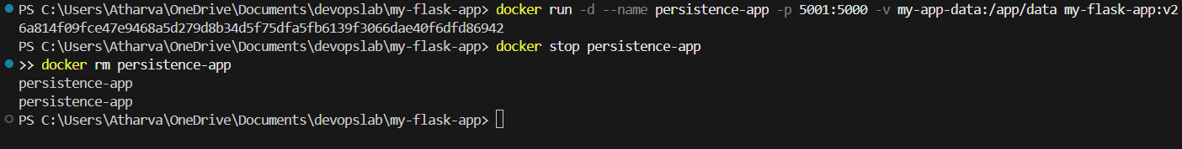

New container, same volume — Ran a fresh container from the same image, mounting the same my-app-data volume; Docker assigned a new container ID, confirming this is a completely separate container instance.

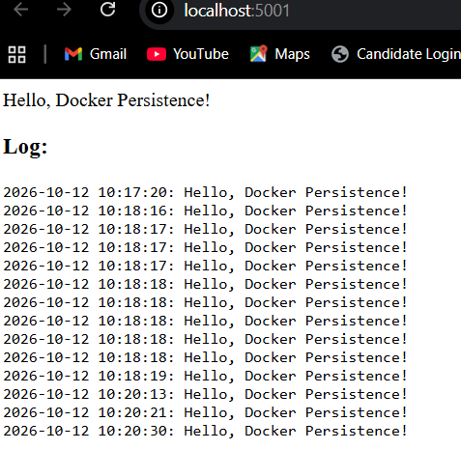
Persistence verified — Accessed the app again — the log showed all prior entries from the deleted container plus new ones from this session, proving data persisted independently of container lifecycle via the named volume.

